CC-1

Question1.

**package** cc;

**import** org.openqa.selenium.By;

**import** org.openqa.selenium.WebDriver;

**import** org.openqa.selenium.firefox.FirefoxDriver;

**import** org.openqa.selenium.chrome.ChromeDriver;

**import** io.github.bonigarcia.wdm.WebDriverManager;

**public** **class** Ques1 {

**public** **static** **void** main(String args[]) {

WebDriverManager.*chromedriver*().setup();

WebDriver driver = **new** FirefoxDriver();

driver.get("https://www.saucedemo.com/");

driver.findElement(By.*id*("user-name")).sendKeys("standard_user");

driver.findElement(By.*id*("password")).sendKeys("secret_sauce");

driver.findElement(By.*id*("login-button")).click();

driver.findElement(By.*id*("add-to-cart-sauce-labs-bike-light")).click();

String cart = driver.findElement(By.*className*("shopping_cart_badge")).getText();

**if**(cart.equals("1")) {

System.***out***.println("The product was added to the cart");

};

driver.findElement(By.*cssSelector*(".shopping_cart_link")).click();

String pageTitle = driver.findElement(By.*cssSelector*(".title")).getText();

**if**(pageTitle.equals("Your Cart"))

System.***out***.println("The cart contents can be viewed");

driver.findElement(By.*id*("checkout")).click();

pageTitle = driver.findElement(By.*className*("title")).getText();

**if**(pageTitle.contains("Your Information")) {

System.***out***.println("The checkout page is displayed");

}

driver.findElement(By.*id*("first-name")).sendKeys("PRANESH");

driver.findElement(By.*id*("last-name")).sendKeys("SJ");

driver.findElement(By.*id*("postal-code")).sendKeys("9876589");

driver.findElement(By.*id*("continue")).click();

**if**(driver.findElement(By.*className*("title")).getText().contains("Overview")) {

System.***out***.println("The Overview is Displayed");

}

String productName = driver.findElement(By.*cssSelector*(".inventory_item_name")).getText();

String productPrice = driver.findElement(By.*cssSelector*(".inventory_item_price")).getText();

System.***out***.println("Product name: " + productName);

System.***out***.println("Product price: " + productPrice);

**if**(driver.getTitle().equals("Swag Labs"))System.***out***.println("The title is verified");

**if**(driver.getCurrentUrl().equals("https://www.saucedemo.com/checkout-step-two.html")) System.***out***.println("The URL is verified");

}

}

OUTPUT:

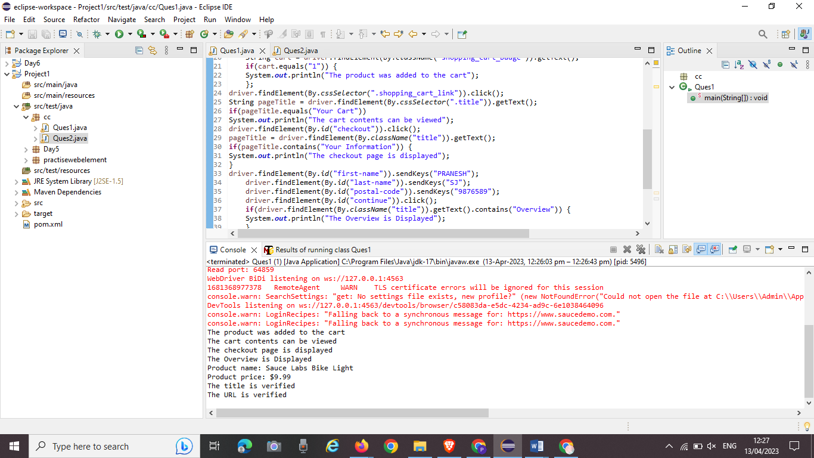

Question2.

**package** cc;

**import** org.openqa.selenium.By;

**import** org.openqa.selenium.WebDriver;

**import** org.openqa.selenium.WebElement;

**import** org.openqa.selenium.firefox.FirefoxDriver;

**import** org.openqa.selenium.support.ui.Select;

**import** io.github.bonigarcia.wdm.WebDriverManager;

**public** **class** Ques2 {

**public** **static** **void** main( String[] args ) **throws** InterruptedException

{

WebDriverManager.*firefoxdriver*().setup();

WebDriver driver = **new** FirefoxDriver();

driver.manage().window().maximize();

driver.navigate().to("https://www.saucedemo.com/");

driver.manage().window().maximize();

WebElement txtBoxl=driver.findElement(By.*xpath*("//*[@id=\"user-name\"]"));

txtBoxl.sendKeys("standard_user");

WebElement txtBox2=driver.findElement(By.*xpath*("//*[@id=\"password\"]"));

txtBox2.sendKeys("secret_sauce");

driver.findElement(By.*xpath*("//*[@id=\"login-button\"]")).click();

String txt1=driver.findElement(By.*xpath*("//*[@id=\"item_4_title_link\"]/div")).getText();

System.***out***.println(txt1);

driver.findElement(By.*xpath*("//*[@id=\"header_container\"]/div[2]/div/span/select")).click();

driver.findElement(By.*xpath*("//*[@id=\"header_container\"]/div[2]/div/span/select/option[2]")).click();

String txt2=driver.findElement(By.*xpath*("//*[@id=\"item_3_title_link\"]/div")).getText();

System.***out***.println(txt2);

driver.findElement(By.*xpath*("//*[@id=\"header_container\"]/div[2]/div/span/select")).click();

driver.findElement(By.*xpath*("//*[@id=\"header_container\"]/div[2]/div/span/select/option[3]")).click();

String txt3=driver.findElement(By.*xpath*("//*[@id=\"item_2_title_link\"]/div")).getText();

System.***out***.println(txt3);

driver.findElement(By.*xpath*("//*[@id=\"header_container\"]/div[2]/div/span/select")).click();

driver.findElement(By.*xpath*("//*[@id=\"header_container\"]/div[2]/div/span/select/option[4]")).click();

String txt4=driver.findElement(By.*xpath*("//*[@id=\"item_5_title_link\"]/div")).getText();

System.***out***.println(txt4);

Thread.*sleep*(5000);

}

}

OUTPUT:

